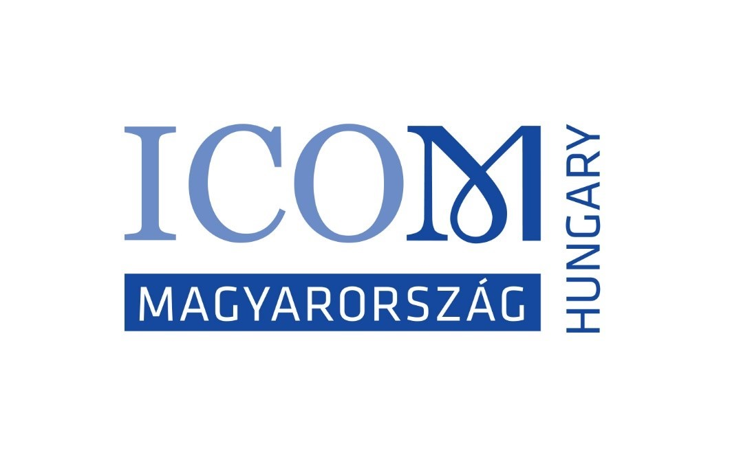 | FELVÉTELI ADATLAP  INTÉZMÉNYI TAGOK RÉSZÉRE  ICOM Magyarország H-1014 Budapest Szent György tér 2.  e-mail: icom.mnb@gmail.hu

Kérjük, hiánytalanul töltse ki a magyar és az angol nyelvű kérelmet is!
AZ ADATOK FELDOLGOZÁSA 6-8 HETET VESZ IGÉNYBE – MEGÉRTÉSÉT ÉS TÜRELMÉT KÉRJÜK!
Az intézmény neve magyarul:
Az intézmény neve angolul:
Ország:
Az intézmény címe: irányítószám:
város:
utca:
házszám:
Az ICOM-mal történő kapcsolattartás során használni kívánt e-mail-cím:
Az ICOM-mal kapcsolatot tartó neve, beosztása:

Az intézmény ICOM MNB tagságának kezdete:

Intézményük összesen három, Önök által választott Nemzetközi Bizottságban kap szavazati jogot.
Vagy egy képviselőnél tüntetnek fel három bizottságot (rövidítve), vagy három képviselőnél egy-egy bizottságot.

Az intézményt képviselő (1.) neve:
Beosztása:
Telefonszáma: e-mail-címe:
Melyik nemzetközi bizottság(ok)ban képviseli intézményét?

Az intézményt képviselő (2.) neve:
Beosztása:
Telefonszáma: e-mail-címe:
Melyik nemzetközi bizottságban képviseli intézményét?

Az intézményt képviselő (3.) neve:
Beosztása:
Telefonszáma: e-mail-címe:
Melyik nemzetközi bizottságban képviseli intézményét?

Volt-e már ICOM-tag? □ IGEN □ NEM
Tagsági kártyája megvan-e? □ IGEN □ NEM Ha igen, kártyaszáma: ……………….

Adatait bizalmasan kezeljük, csak az ICOM statisztikáihoz, kommunikációhoz használjuk, azokat más szervezetek részére nem adjuk ki!

Alulírott tudomásul veszem, hogy az éves tagság január 1-jétől december 31-ig érvényes.
Kijelentem, hogy intézményem a kulturális és természeti örökség kereskedelmében nem vesz részt és intézményemre nézve kötelezőnek fogadom el az ICOM Etikai Kódexét.

Dátum: Aláírás:
Tel + 33 (0) 1 47 34 05 00  Fax + 33 (0) 1 43 06 78 62  E-mail: membership@icom.museum  http://icom.museum | INSTITUTIONAL MEMBERSHIP  APPLICATION FORM  Please complete legibly and return to your National Committee  http://icom.museum/the-committees/national-committees

Name of institution in English (required):
Name of institution in your language :
Date of establishment (dd/mm/yy): Website:
Name of your Museum Director:
Institution contact details

Mailing address :

Postal code : E-mail:

City: Telephone:

Country : Fax:

Institution Designated Representatives and ICOM International Committee Memberships
Institutions can designate up to three of its employees, called designated representatives, to represent them on International Committees. This means that an institution may choose a Committee, and designate three representatives to this Committee.
Or, the institution may choose three different International Committees, and designate the same or different representatives to these Committees.
For more information on the ICOM International Committees, please see
http://icom.museum/the-committees/international-committees

Representative 1:
First Name and Last Name : Mr/Mrs/Ms/Prof/Dr______________________________________________________________
Position: E-mail: Telephone:
International Committee:
Representative 2:
First Name and Last Name : Mr/Mrs/Ms/Prof/Dr______________________________________________________________
Position: E-mail: Telephone:
International Committee:
Representative 3:
First Name and Last Name : Mr/Mrs/Ms/Prof/Dr______________________________________________________________
Position: E-mail: Telephone:
International Committee:
Language for correspondence: (tick one) □English □French □Spanish

Category of membership (based on the annual operating budget of the institution, less capital expenditures):
- □ Regular I (voting) < €30.000
- □ Regular II (voting) from €30.000 to €100.000
- □ Regular III (voting) from €100.000 to €1.000.000
- □ Regular IV (voting) from €1.000.000 to €5.000.000
- □ Regular V (voting) from €5.000.000 to €10.000.000
- □ Regular VI (voting) > €10.000.000
- □ Sustaining (voting)
- □ Contributing (voting)
- □ Supporting (non-voting)

Membership is annual and runs from January 1 to December 31 of the year.

Please tick the classification which apply to your institution:

A. CATEGORY OF INSTITUTION:
❑ Archives with Special Collections | ❑ Museum Service Companies and Consultants
❑ Botanical Garden | ❑ Natural Park
❑ Conservation Institute | ❑ Other Cultural Institutions/Centers
❑ Corporate Collections | ❑ Places of Worship
❑ Exhibition Gallery | ❑ Professional Association/Federation
❑ Government Agency | ❑ Research/Training Institute in Museum Studies
❑ Library with Special Collections | ❑ Zoo /Animal Reserve
❑ Monuments and Sites | OTHERS (please specify):
❑ Museum

B. GOVERNING BODY:
❑ Association | ❑ National
❑ City or Municipal | ❑ Private
❑ Foundation, Society, Trust | ❑ Region or Local
❑ International Organisation | ❑ University
 | OTHERS (please specify):

C. TYPE OF COLLECTION:
❑ Agriculture/Rural Heritage   Archaeology   Architecture   Audiovisual and Digital Art   Children's Museum   Decorative and Applied Arts and Design   Egyptology   Ethnology/Ethnography   Glass and Ceramics   Historic Houses and Gardens   History   Human Rights | ❑ Military History   Modern/Contemporary Art
 | ❑ Money or Bank Museum
 | ❑ Music
 | ❑ Natural Sciences
 | ❑ Open Air
 | ❑ Paintings and Graphic Arts
 | ❑ Performing Arts
 | ❑ Photography and Film
 | ❑ Prehistory
 | ❑ Science and Technology
 | ❑ Sculpture
❑ Industrial Heritage |  Sports
❑ Literature |  Textiles, Costume and Accessories 
 Maritime | ❑ Transport and Communications
❑ Medicine, Health and Hygiene | OTHERS (please specify):

Note: The above information will be automatically processed to ensure your receipt of services from ICOM. In conformity with the French Law on Informatics & Civil Liberties (Jan. 6, 1978, rev.) you have the right of access and to modify the information that concerns you.

I, , declare that my institution is eligible for membership of the International Council of Museums (ICOM) and wishes to become a member of ICOM.
My institution does not engage in dealing (i.e. buying and selling for profit) in the field of cultural property and accepts the ICOM Code of Ethics for Museums.

Date: April 2023 Signature:

APPLICATION FORM
INTERNATIONAL COMMITTEE MEMBERSHIP
FOR INVIDIDUAL MEMBERS AND INSTITUTION REPRESENTATIVES
ICOM Secretariat
Maison de l'UNESCO - 1, rue Miollis - 75732 Paris Cedex 15 - France
Tel: + 33 (0) 1 47 34 05 00 Fax: + 33 (0) 1 43 06 05 54
Email: membership@icom.museum Website: http://icom.museum
JOIN THE ICOM INTERNATIONAL COMMITTEES!
With your ICOM individual or institutional membership, you can join ICOM’s International Committees, which represent different types of museum collections and professions.
Institutions can designate up to three of its employees, called designated representatives, to represent them on International Committees. This means that an institution may choose a Committee, and designate three representatives to this Committee. Or, the institution may choose three different International Committees, and designate the same or different representatives to these Committees.
By joining an International Committee:
- - You will receive up-to-date news from the International Committee, and have access to their publications and newsletters.
- - You may participate in their annual meetings and other activities, with preferential rates.
- - You may participate in the discussions among colleagues of the International Committee.
- - You can take part in joint activities organised with other ICOM International Committees, ICOM National Committees and other organisations.
- - You can join the special interest or working groups of some International Committees.

INDIVIDUAL MEMBERS AND INSTITUTION DESIGNATED REPRESENTATIVES
If you have not yet joined any International Committee or if you wish to change your International Committee, please choose:
- - one (1) in which you have voting rights (except Student and Supporting members):
- - up to three (3) in which you are interested in order to receive information from them:

Archaeology & History (ICMAH)
Architecture & Museum Techniques (ICAMT)
Arms & Military History (ICOMAM)
Audio-visual & New Technologies (AVICOM)
Conservation (ICOM-CC)
Decorative Arts and Design (ICDAD)
Collecting (COMCOL)
COSTUME
Documentation (CIDOC)
Education & Cultural Action (CECA)
Egyptology (CIPEG)
Ethnography (ICME)
Exhibition Exchange (ICEE)
Fine Arts (ICFA)
GLASS
Historic House Museums (DEMHIST)
Literary Museums (ICLM)
Management (INTERCOM)
Marketing & Public Relations (MPR)
Memorial Museums (IC MEMO)
Money & Banking Museums (ICOMON)
Museology (ICOFOM)
Museum Security (ICMS)
Museums of Cities (CAMOC)
Musical Instruments (CIMCIM)
Natural History (NATHIST)
Regional Museums (ICR)
Science & Technology (CIMUSET)
Training of Personnel (ICTOP)
University Museums (UMAC)

For more information on the ICOM International Committees, please see http://icom.museum/the-committees/international-committees.
First Name: | Last Name:
ICOM Individual or Institution card number:
E-mail:  Date: | Signature:
Note: The above information will be automatically processed to ensure your receipt of services from ICOM. In conformity with the French law on Informatics & Civil Liberties (Jan. 6, 1978, rev.) you have the right of access and to modify the information that concerns you.

April 2023

